**Vivekanand Education Society’s Institute of Technology**

**Department of Computer Engineering**

**TIFR - VESIT Collaboration Project**

**Minutes of the Meeting**

**Venue : Online (Google Meet)**

**Date : 25th January 2023**

**Participants Attendance List:**

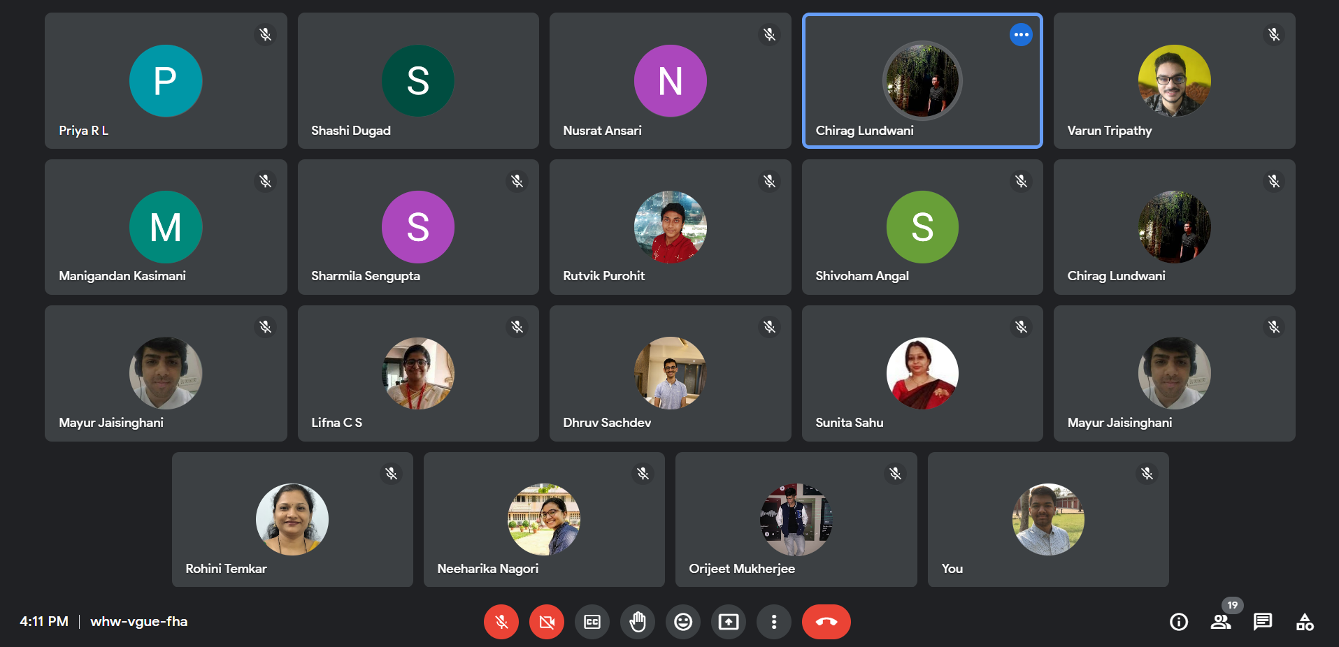

**Agenda:**

● To show the tasks assigned to students previously

● To discuss the next plan of action at work.

**Point Discussed:**

* Wireless text detection group was asked to show text recognition for the next meet along with text detection using the YOLO model and comparison of all models used till date. Individual characters from the video provided need to be detected and recognized.
* Gujarati Script Recognition group was asked to refine the new model and work on image preprocessing.
* Physical Object identification in the CMS experiments group has been asked to explain GNN with a program via PPT . We also have to figure out ways on how to implement GNN on the dataset provided. Further we have to explore the dataset.